**INSTITUTE OF COMPUTER TECHNOLOGY**

**B. Tech CSE (BDA) Sem-VI**

**Subject: Cognitive Computing**

**Assignment 1**

**Q)** **In the current National emergency observation of COVID-19 everyone should follow the guidelines to stay out of the infection and wearing the mask is one of them. Government need to keep monitoring on the citizen to follow the guideline with the help of IBM Visual Recognition train a Model to identify people who wearing mask or not in the public place.**

1) Firstly, create a new project and add visual recognition service into it.

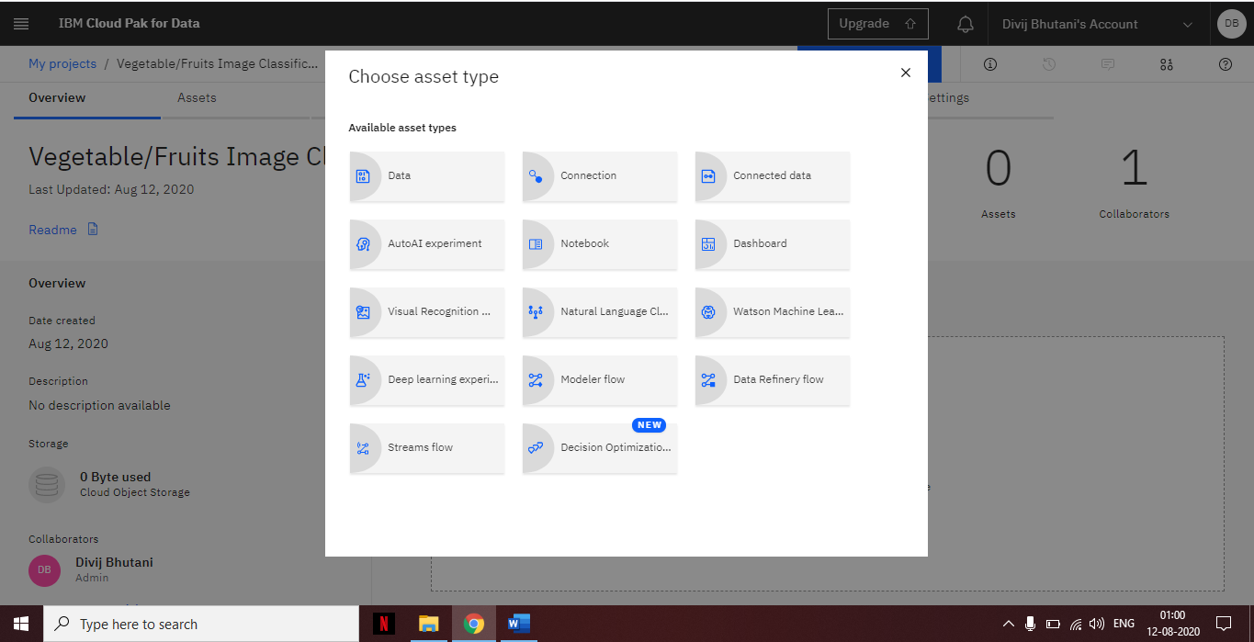

2) Add the Visual Recognition service.

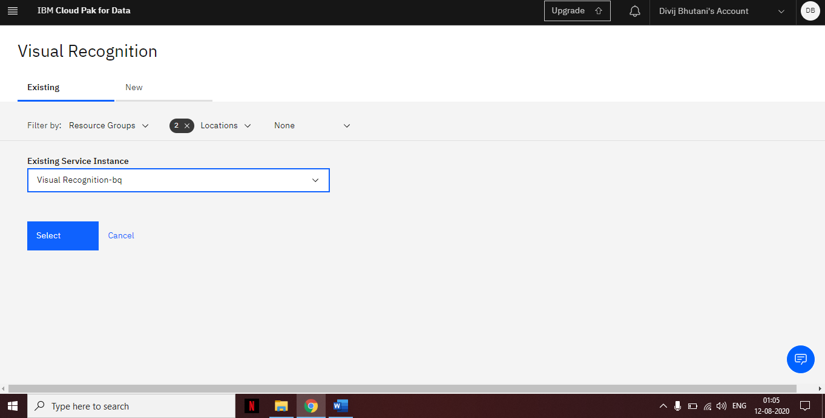

3) Now choose the model you want to create; in our case it is Detect Objects.

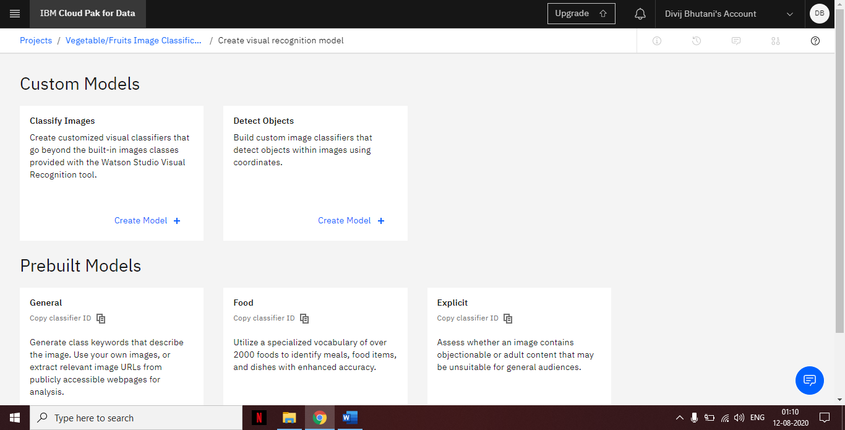

4) Now upload your image data into the model.

5) Now to detect whether man has worn mask or not, label the objects by selecting them and give a suitable name to it, in our case it is mask and no mask.

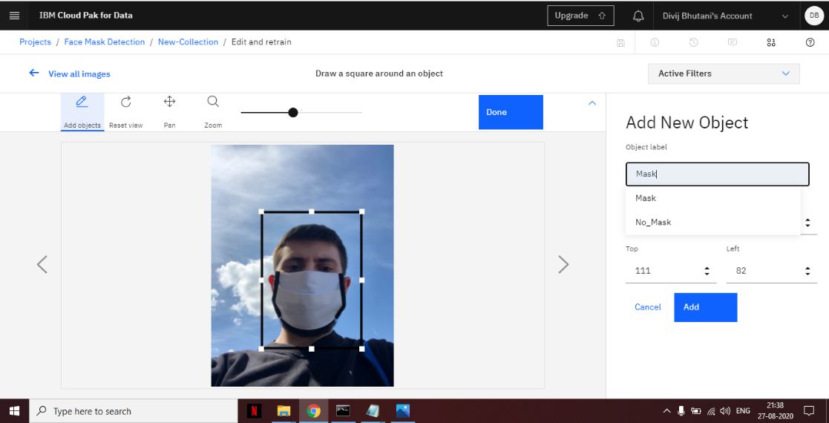

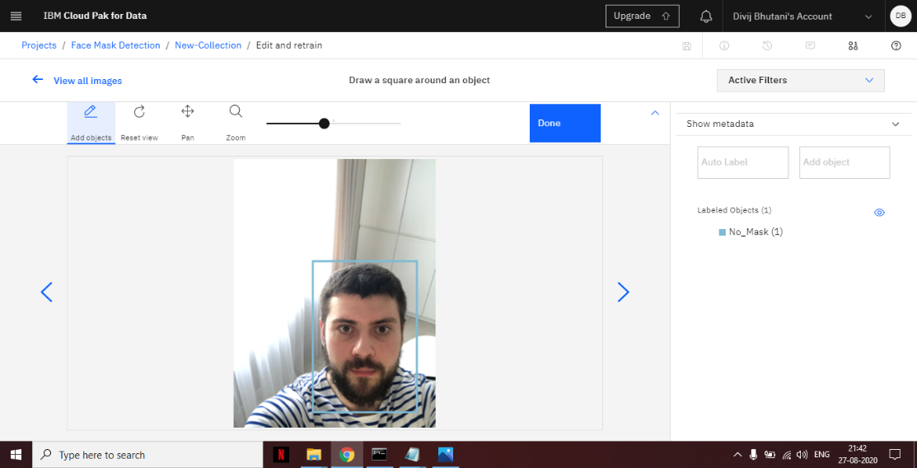

6) Press train model button to train the model, as you can see model has started training.

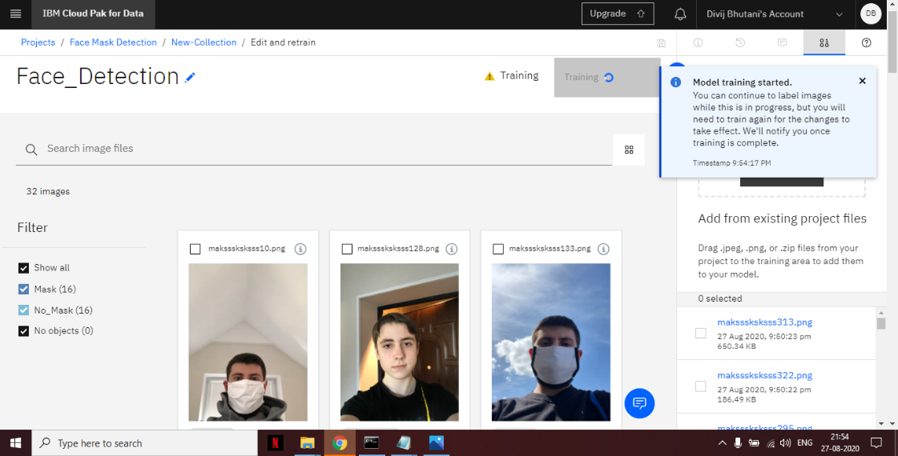

7) As you can see model is trained successfully. Now we will move on to test the model.

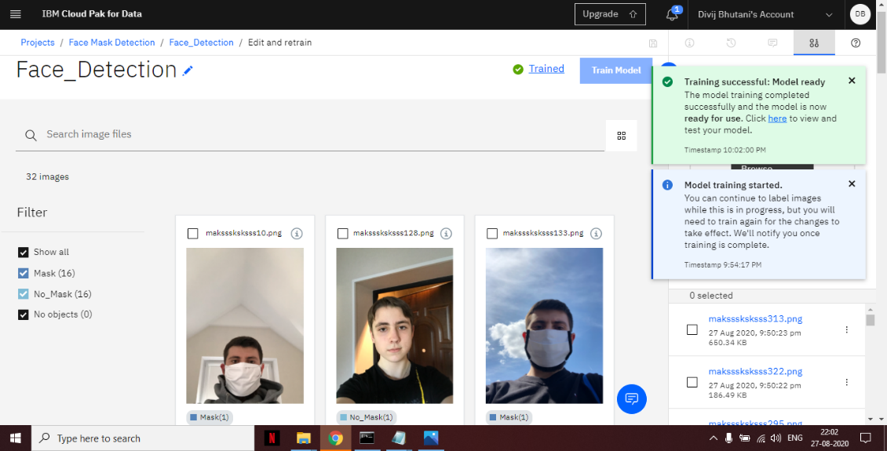

8) Now it’s time to test our model. To test the model, go to the Test option and then upload image to see whether our model can detect them correctly. As you can see our model has rightly classified the image with a confidence of 0.83.

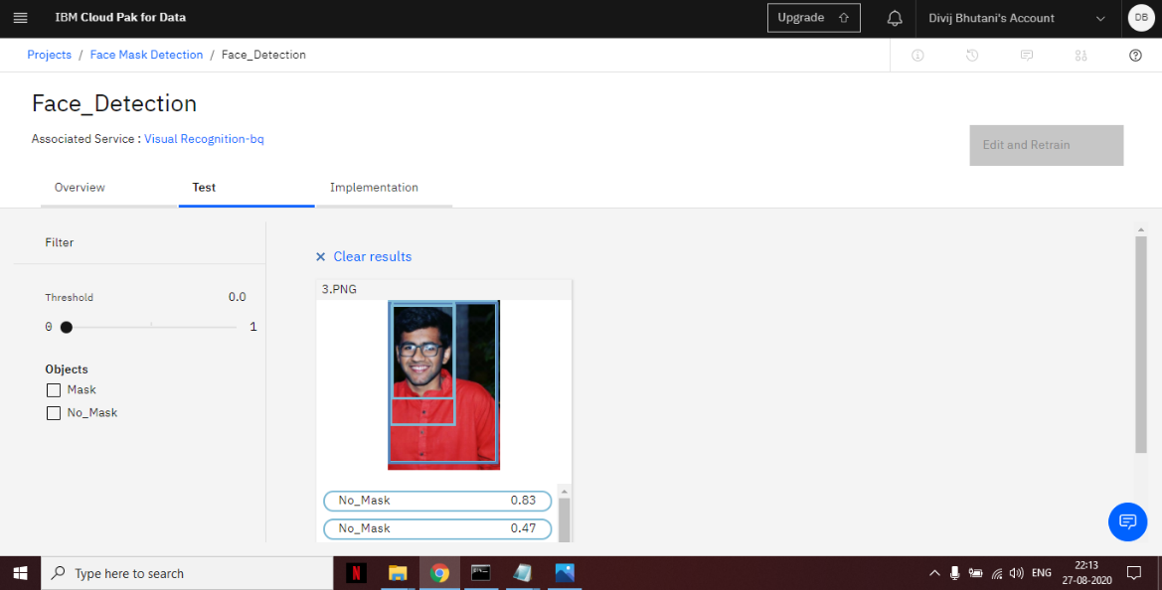

**Q) Observing the current nation emergency scenario whoever is**

**infected required quick attention. Idea is with the help of IBM**

**Watson Assistant build an assistant that can ask all symptoms related**

**to COVID-19 and provide nearest health center detail to respective**

**area.**

**Dialog Flow:**

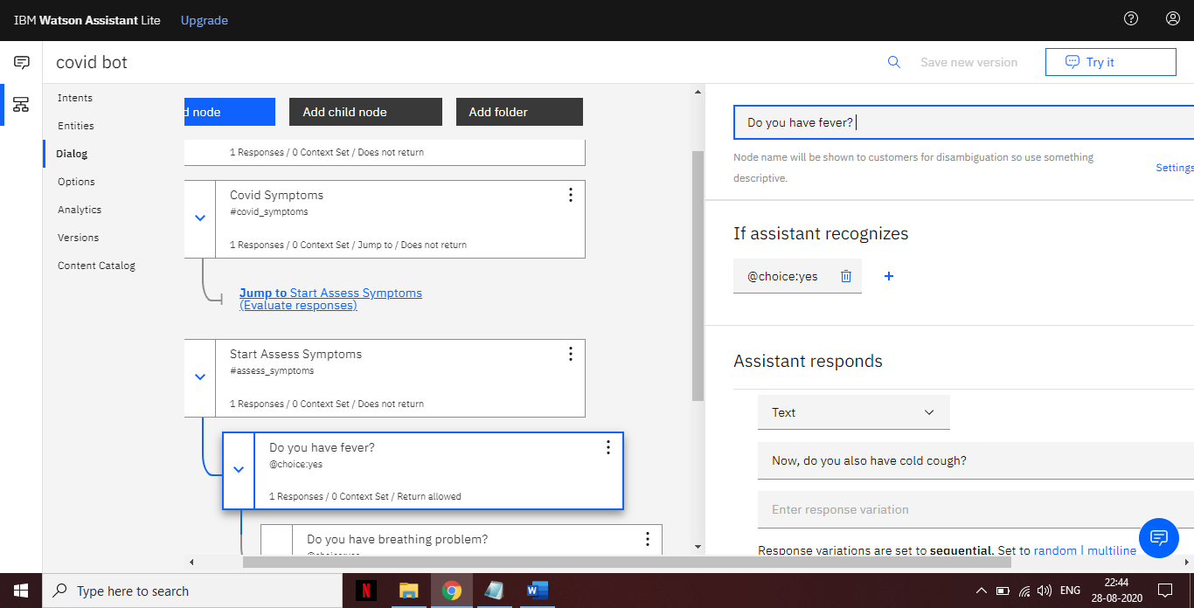

**Intents:**

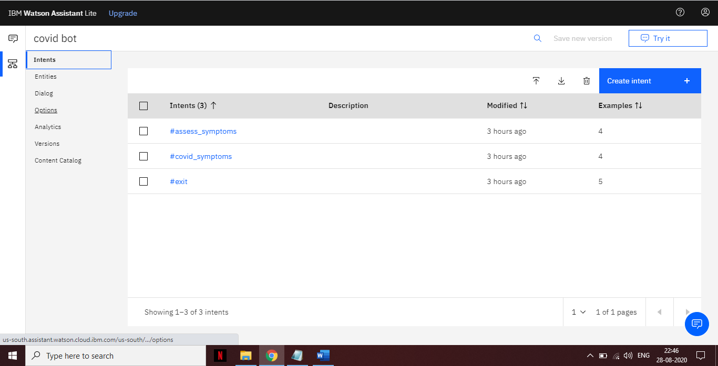

**Entities:**

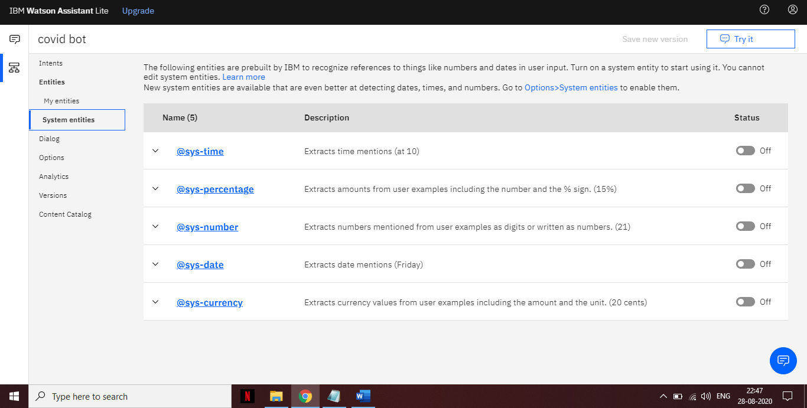

**Bot Link:** <https://web-chat.global.assistant.watson.cloud.ibm.com/preview.html?region=us-south&integrationID=8403bc10-7156-4bfb-ae70-13ddd65b2dfc&serviceInstanceID=8f8de68a-fe6e-4d7c-a36f-7165359a1550>

